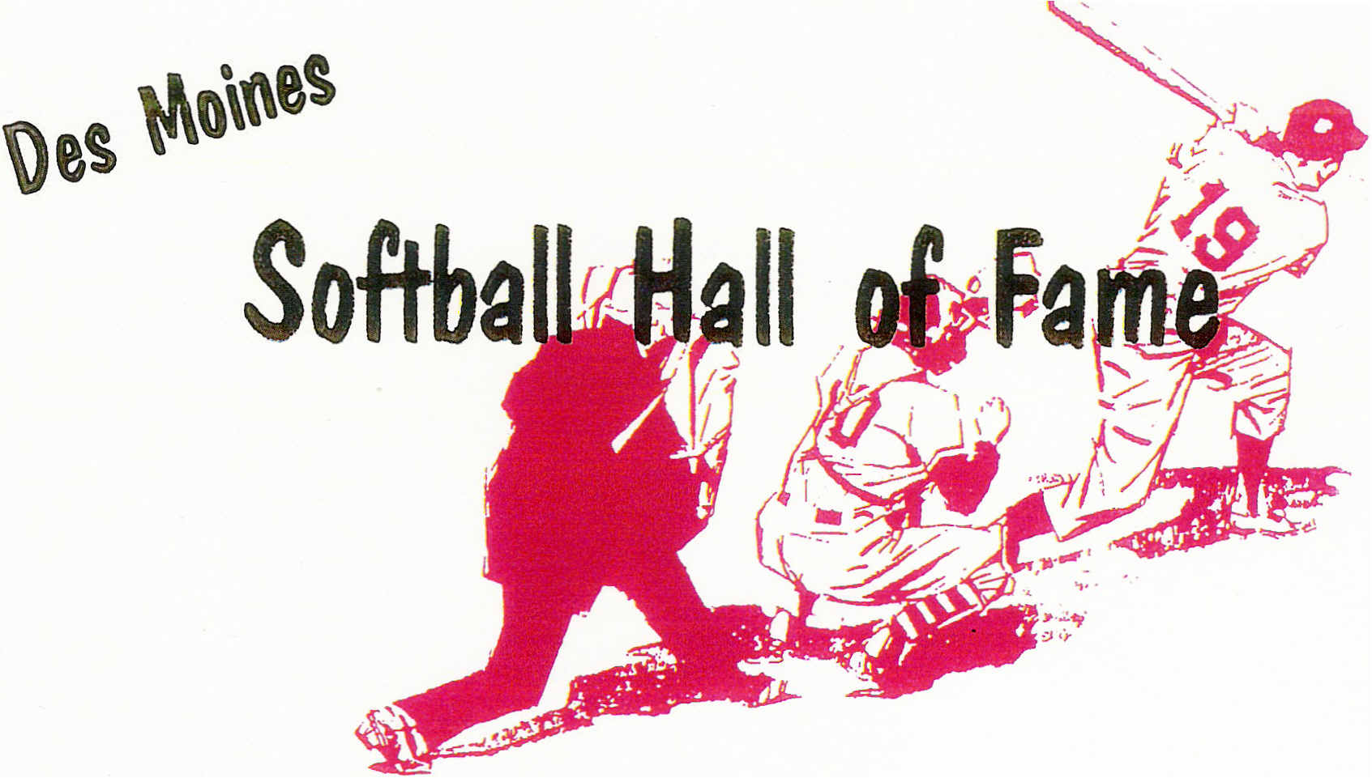

OFFICERS
Mike Clark President
Kevin Walker Vice President
Tony Nelson Secretary
Chuck Welker Treasurer
dmfastpitch@hotmail.com

HOF Meeting Minutes
November 17th @ Hilltop Pizza

Meeting was called to order at 7:05pm.

In Attendance: Oscar Calkins, Dave Temple, Al Van Dyke, Gordy Baker, Gene Olsen, Mike Clark, Kevin Walker, Chuck Welker, Jary Hoskey, John Kelly, Roger Aceto, Randy Ripperger, Tony Nelson

Agenda:
- Options for moving forward with the Hall of Fame
- Site for the HOF
- Vision for displaying our HOF memorabilia
- Estimated Cost for building the display case
- Fund Raising

Mike Clark led discussion of the 3 options for the HOF – discontinuing the HOF, continuing w/o a permanent home, or continuing the HOF and securing a new permanent location.

Chuck Welker advised of several business locations that had expressed interest in hosting the HOF, however, those locations would not commit to providing a permanent room and display for the HOF. Hilltop did give us this commitment.
The estimated cost to build the new display case was approx $3,200. Chuck presented the layout/design of the display and the itemized estimate. One item to note – Hilltop is requesting the electrical work be completed by their electrician. Everyone agreed that would be acceptable. Upon collecting enough pledges, we hope to complete construction on the new display area by Feb 1st, 2011.

Fund Raising - it was discussed and decided that the best option to raise funds for the HOF would be to get commitments from our current members. Members of the HOF should be motivated and engaged enough to strive for seeing our tradition continue – thus we need to each step up and give towards our transition to Hilltop and building the new display area. Additionally, those members that can solicit funds from sponsors are encouraged to do so.

A vote was taken to see what options we wanted to take – the vote was unanimous 13-0 to continue the HOF in a new location (Hilltop).

We also had fundraising commitments from each member in attendance as follows:

Grand Slam ($500 or more)
Chuck Welker

Home Run ($250)
Dave Temple, Gordy Baker, Al Van Dyke, Gene Olsen, Mike Clark, John Kelly Roger Aceto

Triple ($200)
Kevin Walker, Jary Hoskey, Oscar Calkins

Double ($150)
Randy Ripperger

Single ($100)
Tony Nelson

The total commitment from our members in attendance totaled $3,100. This is a good start towards funding the display area and rebuilding our treasury for future HOF needs. We are looking for the rest of the HOF members to also pledge towards our efforts as well.

At the bottom of this document will be the address to Chuck Welker and Mike Clark – you can make checks out to the DM Hall Of Fame and mail them to either person. We have set a timeline at collecting funds by January 15th, 2011. Please keep this in mind – this fraternity can only continue with active members. We encourage stronger participation at meetings as well as helping out financially.

Also we need help to secure our membership information – (ie need to track down some of our members for current addresses/phone numbers and/or email addresses). So attached in an email (for those I have records of) will be a list of the current membership. Please take a few moments to help contact those we are missing or have not verified addresses for. Highlighted in yellow are those that have been verified either with an address or email.

Meeting adjourned at 7:55pm.

Any questions, feel free to contact a member of the board.

Tony

Mike Clark (President) – 675 46th St. Des Moines, IA 50312
Chuck Welker (Treasurer) – 4954 Streamside Circle Des Moines, IA 50317

